**REFERENCE LINK – FINAL PROJECT**

Stefanus Jonatan - 2540134956

**ABOUT US**

<https://1qghdw20tywd2qc5uw1w82ap-wpengine.netdna-ssl.com/wp-content/uploads/2019/11/style-festive-family-fashion-feature-768x597.jpeg>

<https://media.architecturaldigest.com/photos/56c647ce00777f0f265e4b89/master/w_1920%2Cc_limit/Paris-Fashion-Shops-02.jpg>

<https://imageio.forbes.com/specials-images/imageserve/5f93f215a388b00bdb41a766/The-retro-Liquid-x-Marvel-collection-/960x0.jpg?format=jpg&width=960>

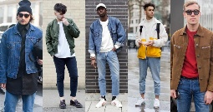

<https://id.pinterest.com/pin/754915956267473916/>

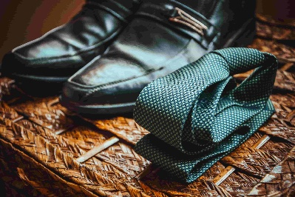

<https://id.pinterest.com/pin/694680311245201354/>

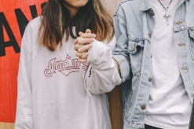

<https://res.cloudinary.com/jerrick/image/upload/f_jpg,fl_progressive,q_auto,w_1024/mgzhjkwzwgirqsguu0dz.jpg>

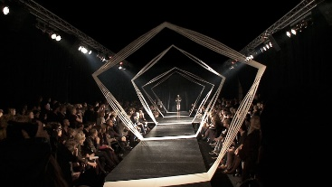

<https://i.pinimg.com/originals/24/50/ce/2450cecd8db9e17b8ee1d78c0d9db1dd.jpg>



<https://toppng.com/free-image/gabe-newell-pointing-PNG-free-PNG-Images_473565>

**HOME**

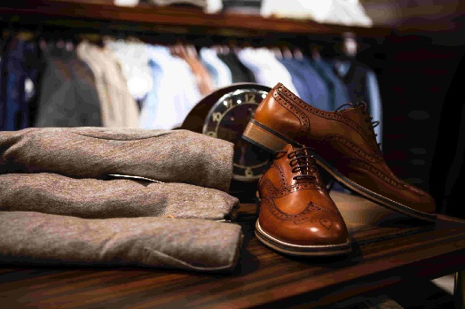

<https://www.pexels.com/photo/pair-of-brown-leather-wingtip-shoes-beside-gray-apparel-on-wooden-surface-298864/>

**PRODUCT**

**TOPS**

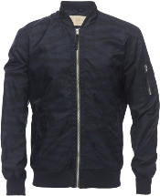

<https://www.pngfind.com/mpng/TihmTxJ_bomber-jacket-in-camo-print-zara-man-jacket/>

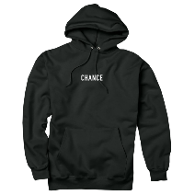

<https://www.pngarts.com/explore/206695>

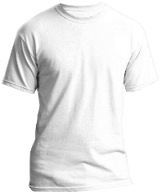

<https://www.pngarts.com/explore/99226>

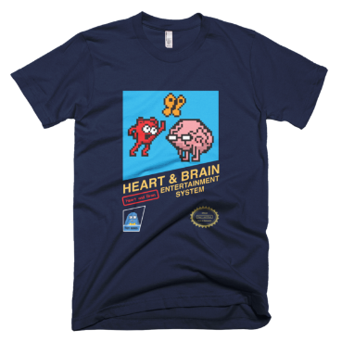

<https://www.pngarts.com/explore/4310>

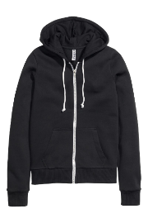

<https://www.pngarts.com/explore/70099>

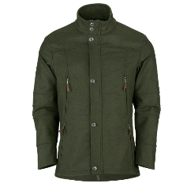

<https://www.pngarts.com/explore/69577>

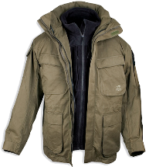

<https://www.pngarts.com/explore/11307>

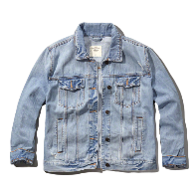

<https://www.pngarts.com/explore/18519>

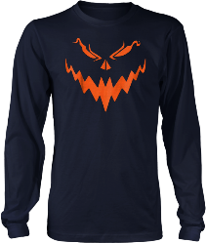

<https://www.pngarts.com/explore/292422>

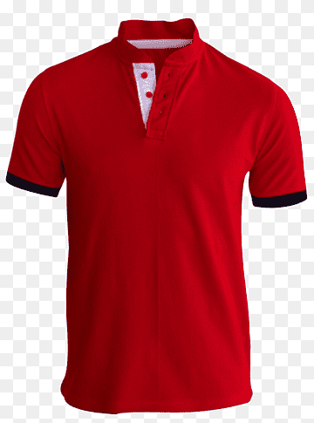

<https://www.pngwing.com/en/free-png-bikru/download/>

**BOTTOMS**

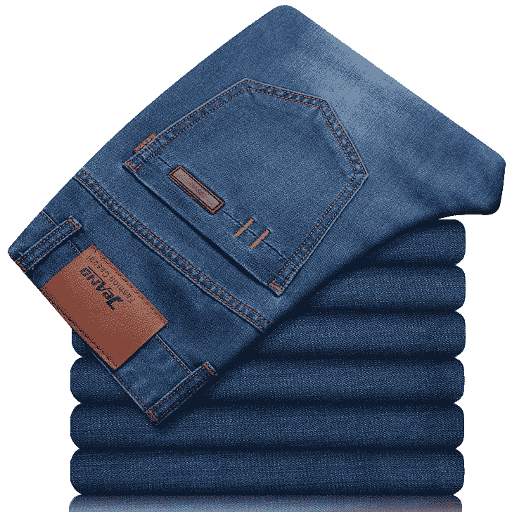

<https://www.pngarts.com/explore/157636>

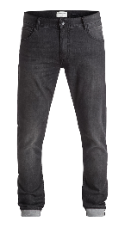

<https://www.pngarts.com/explore/46682>

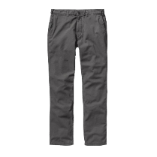

<https://www.pngarts.com/explore/19267>

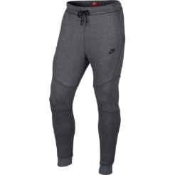

<https://www.pngarts.com/explore/76359>

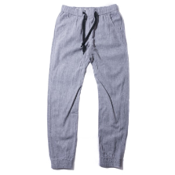

<https://www.pngarts.com/explore/76463>

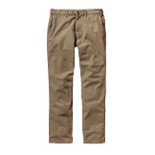

<https://www.pngarts.com/explore/19261>

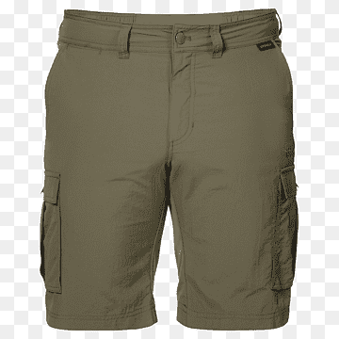

<https://www.pngwing.com/en/free-png-pfzwv/download>

<https://www.kindpng.com/downpng/iJbmRbi_shorts-for-men-png-download-bermuda-shorts-transparent/>

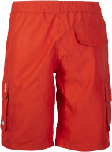

<https://www.nicepng.com/downpng/u2t4t4q8i1i1u2t4_men-shorts-png-pocket/>

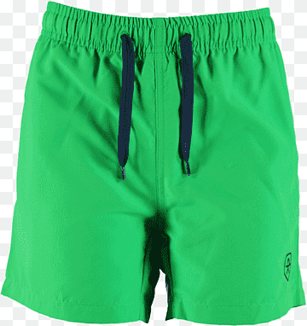

<https://www.pngwing.com/en/free-png-dfwce/download/>

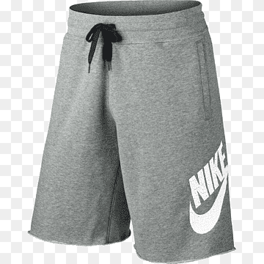

<https://www.pngwing.com/en/free-png-nnnvy/download/>

**LOCATION**

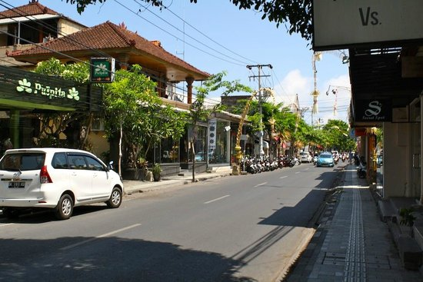

<https://media-cdn.tripadvisor.com/media/photo-s/04/be/4f/8a/favehotel-seminyak.jpg>

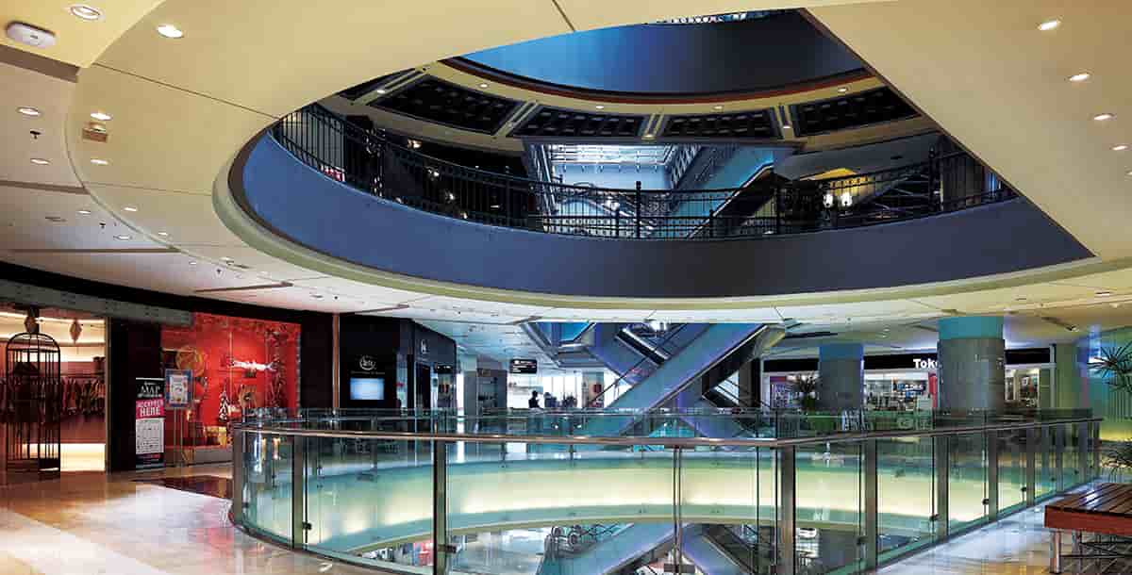

<https://panasonic.net/electricworks/lighting/solutions/grandindonesia/img/visual02.jpg>

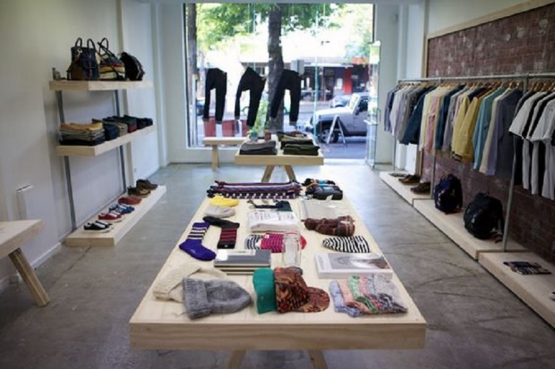

<https://d3p0bla3numw14.cloudfront.net/news-content/img/2020/09/07073034/desain-toko-4.jpg>

<https://dynamic-media-cdn.tripadvisor.com/media/photo-o/0e/fe/fb/17/photo4jpg.jpg?w=1200&h=-1&s=1>

<https://3h40go1k7x4w3f2n2mbwapbf-wpengine.netdna-ssl.com/wp-content/uploads/14-adc-architecture-design-collaborative-retail-court-activation-digital-signage-altamonte-springs-fl.jpg>

<https://live.staticflickr.com/5308/5881091021_8beacf7765_b.jpg>

**FLAG**

A blue field with the Union Flag in the upper hoist quarter, a large white seven-pointed star in the lower hoist quarter, and constellation of five white stars in the fly – one small five-pointed star and four, larger, seven-pointed stars.

<https://upload.wikimedia.org/wikipedia/commons/thumb/8/88/Flag_of_Australia_%28converted%29.svg/125px-Flag_of_Australia_%28converted%29.svg.png>



<https://en.wikipedia.org/wiki/Indonesia#/media/File:Flag_of_Indonesia.svg>



<https://en.wikipedia.org/wiki/Germany#/media/File:Flag_of_Germany.svg>



<https://upload.wikimedia.org/wikipedia/en/a/a4/Flag_of_the_United_States.svg>

**ORIGINAL :**

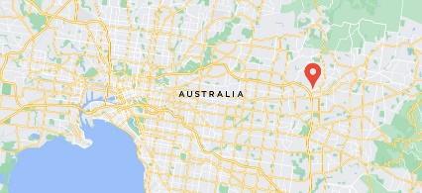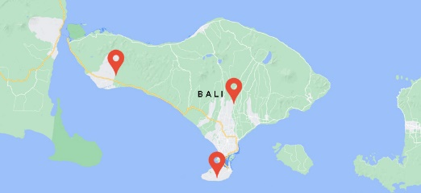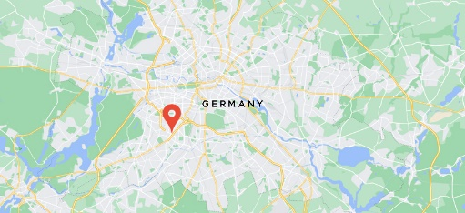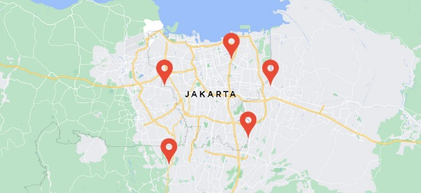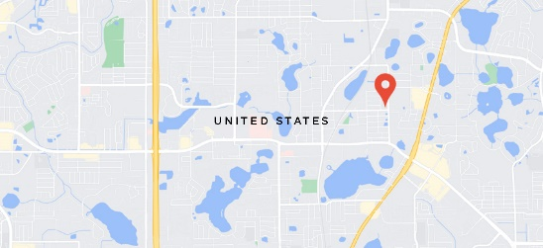

ICON (FIGMA COMMUNITY)

<https://www.figma.com/community/file/1112637659305525156>

<https://www.figma.com/file/zZfCwI1A56SbdkkgzBvfEn/Social-Icons-(Community)?node-id=0%3A1>



LINK VIDEO (Subscribe Page) :

https://www.youtube.com/watch?v=OaVsCM0Zeio